NETWORKING OF MULTIPLE MICROCONTROLLERS

ABSTRACT

The project is designed to demonstrate how multiple microcontrollers can be connected in a network to achieve the desired output. This technology is widely used in modern automobiles. More and more microcontrollers are embedded in different kinds of products from industrial environment to domestic area; a good example is the automobile sector. A modern day car has number of microcontrollers integrated within its system. As this number increases, the networking and communication between them becomes necessary. The importance of having multiple microcontrollers against a single one is if one of the microcontrollers goes bad only the function related to that particular microcontroller will be affected.
The project demonstrates a command based monitoring tool using the RS232 protocol. A network of three microcontrollers is used in this project. The first one is connected to a keypad for input action while the second one is connected to an LCD display and the third one to drive a relay for controlling any load (LAMP). Input takes a password on the first MC to display it on the second MC while the third one executes the output only if the password is right. Wrong password if entered will generate a buzzer sound. Though this task can be performed by a single microcontroller, the project uses multiple microcontrollers to explain the concept of networking. It is practically impossible by a single microcontroller to handle input action, display and output which are located way apart. For example, a display unit requiring 15 connections from the microcontroller needs to be managed using a multi core cable, similarly for a keypad using 7 connections. Thus, for large number of inputs and displays it would require multi core data cable to be connected to the MC running over kilometers, whereas this project uses a pair of wire only thereby reducing the complications in wiring and cost as well.
Further this project being based on serial communication can be enhanced by using wireless communication among the controllers by avoiding costly cabling.

BLOCK DIAGRAM:
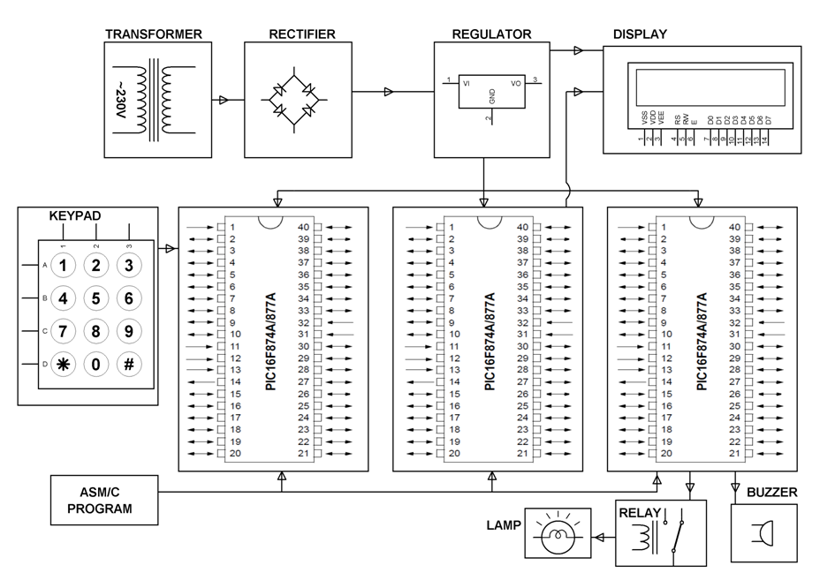

HARDWARE REQUIREMENTS:
PIC series Microcontrollers, Keypad, LCD, Relay, Transformer, Diodes, LED, Resistors, Capacitors, Regulator, Buzzer, Lamp
SOFTWARE REQUIREMENTS:
HI-TECH PICC Tool suite
Language: Embedded C or Assembly

